# SMS與Alert說明

目錄

前言-------------------------------------------------------- 2

儀器故障檢測--------------------------------------------3

門檻值檢測-----------------------------------------------4

其他---------------------------------------------------------5

冷暖天氣提示--------------------------------------------6

Alert---------------------------------------------------------7

SMS Server------------------------------------------------8

Alert Server------------------------------------------------9

另外兩個系統------------------------------------------10

附錄-------------------------------------------------------11

## 前言

1. 位置： pwsv03: /home/cptmain/elsa/data_update_status/
2. 點擊圖片能轉到每項檢測簡介的[網頁](http://tra007.smg.net:9444/auto-s-m-s/readme-detail)
3. SMS Server 的主機在cptv02
4. Alert Server的主機在tra007
5. ThreeMacau 和 Smartone 的API 說明文件方在[cpt_nas01:\Manuals\SMS](Z:\\Manuals\\SMS)

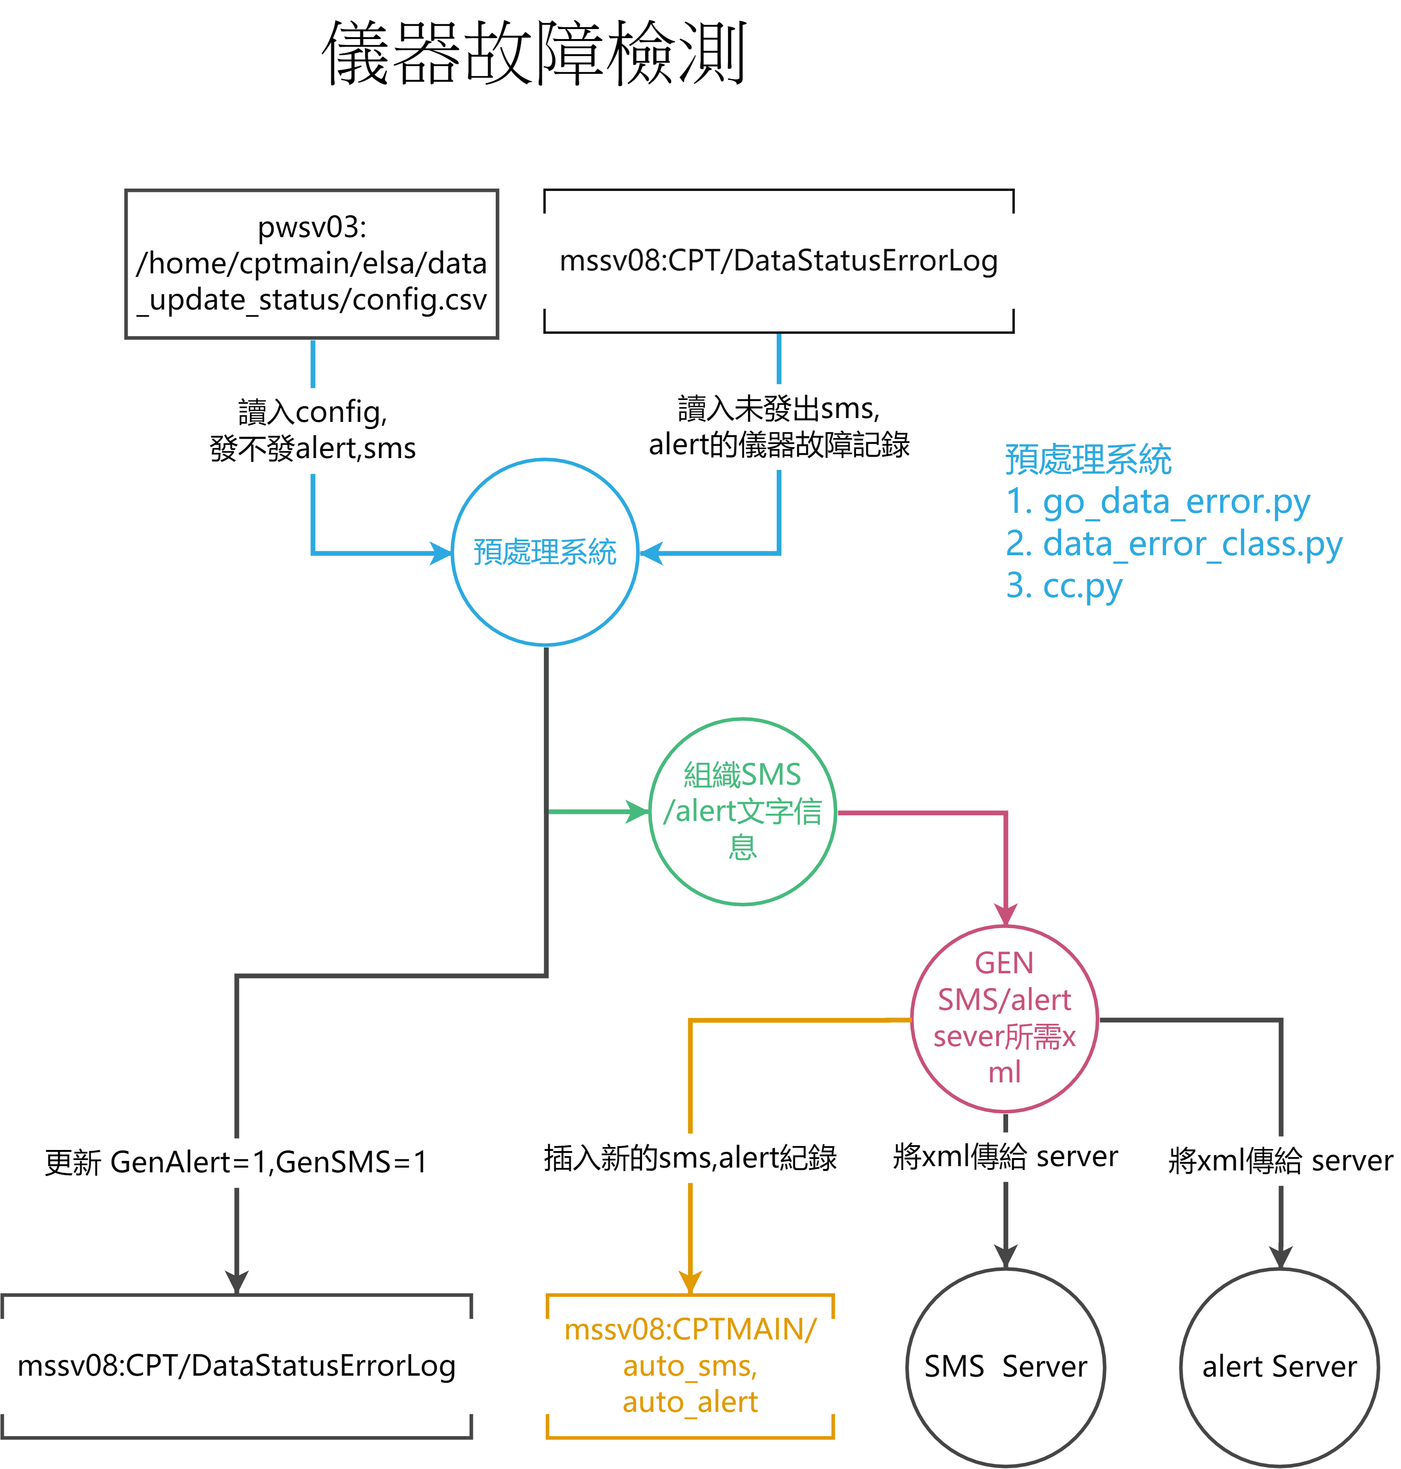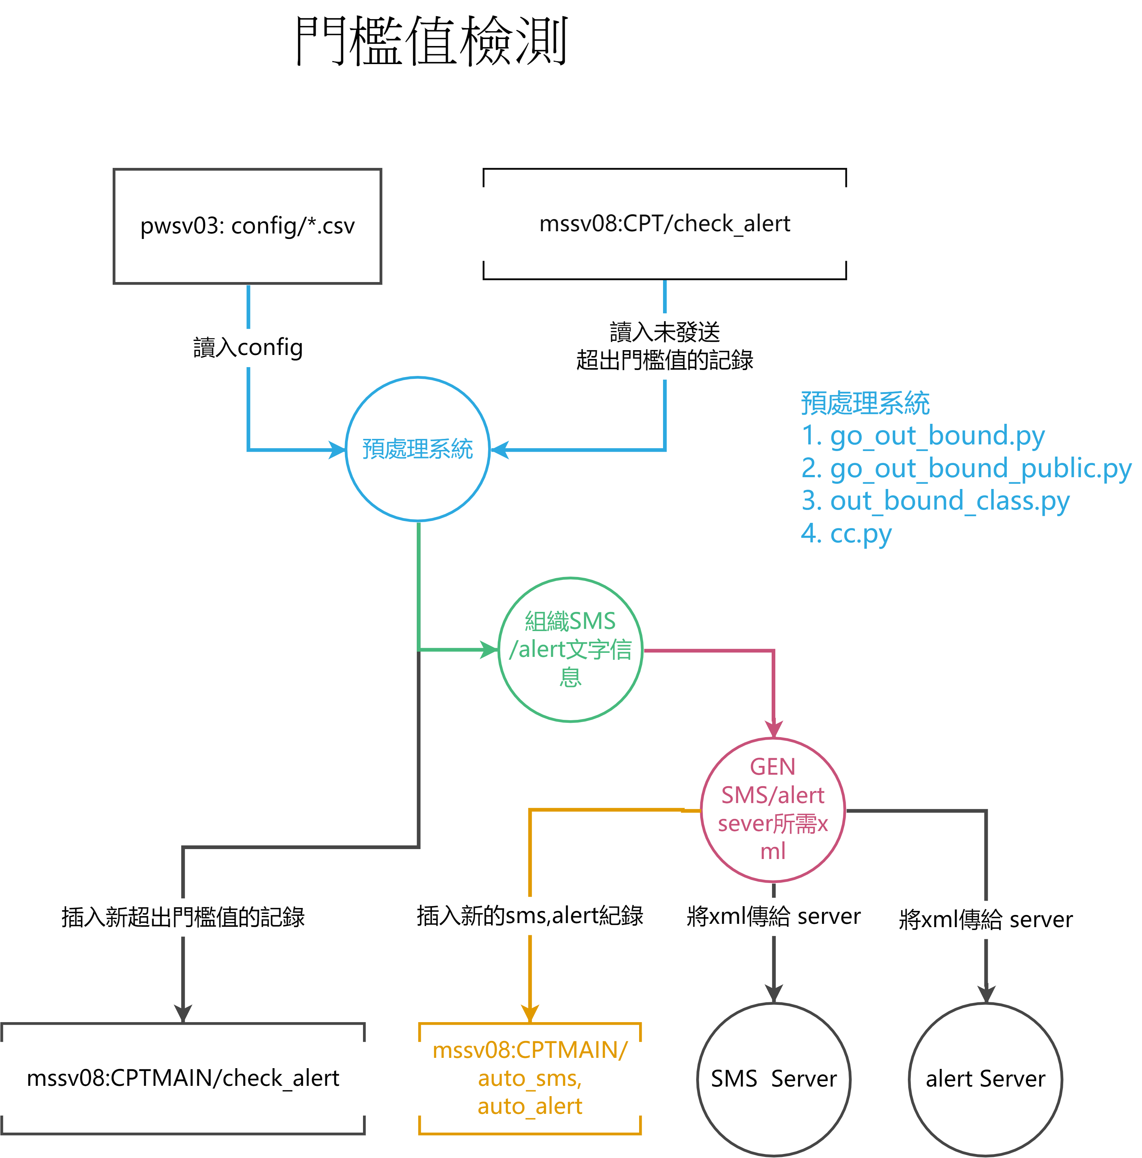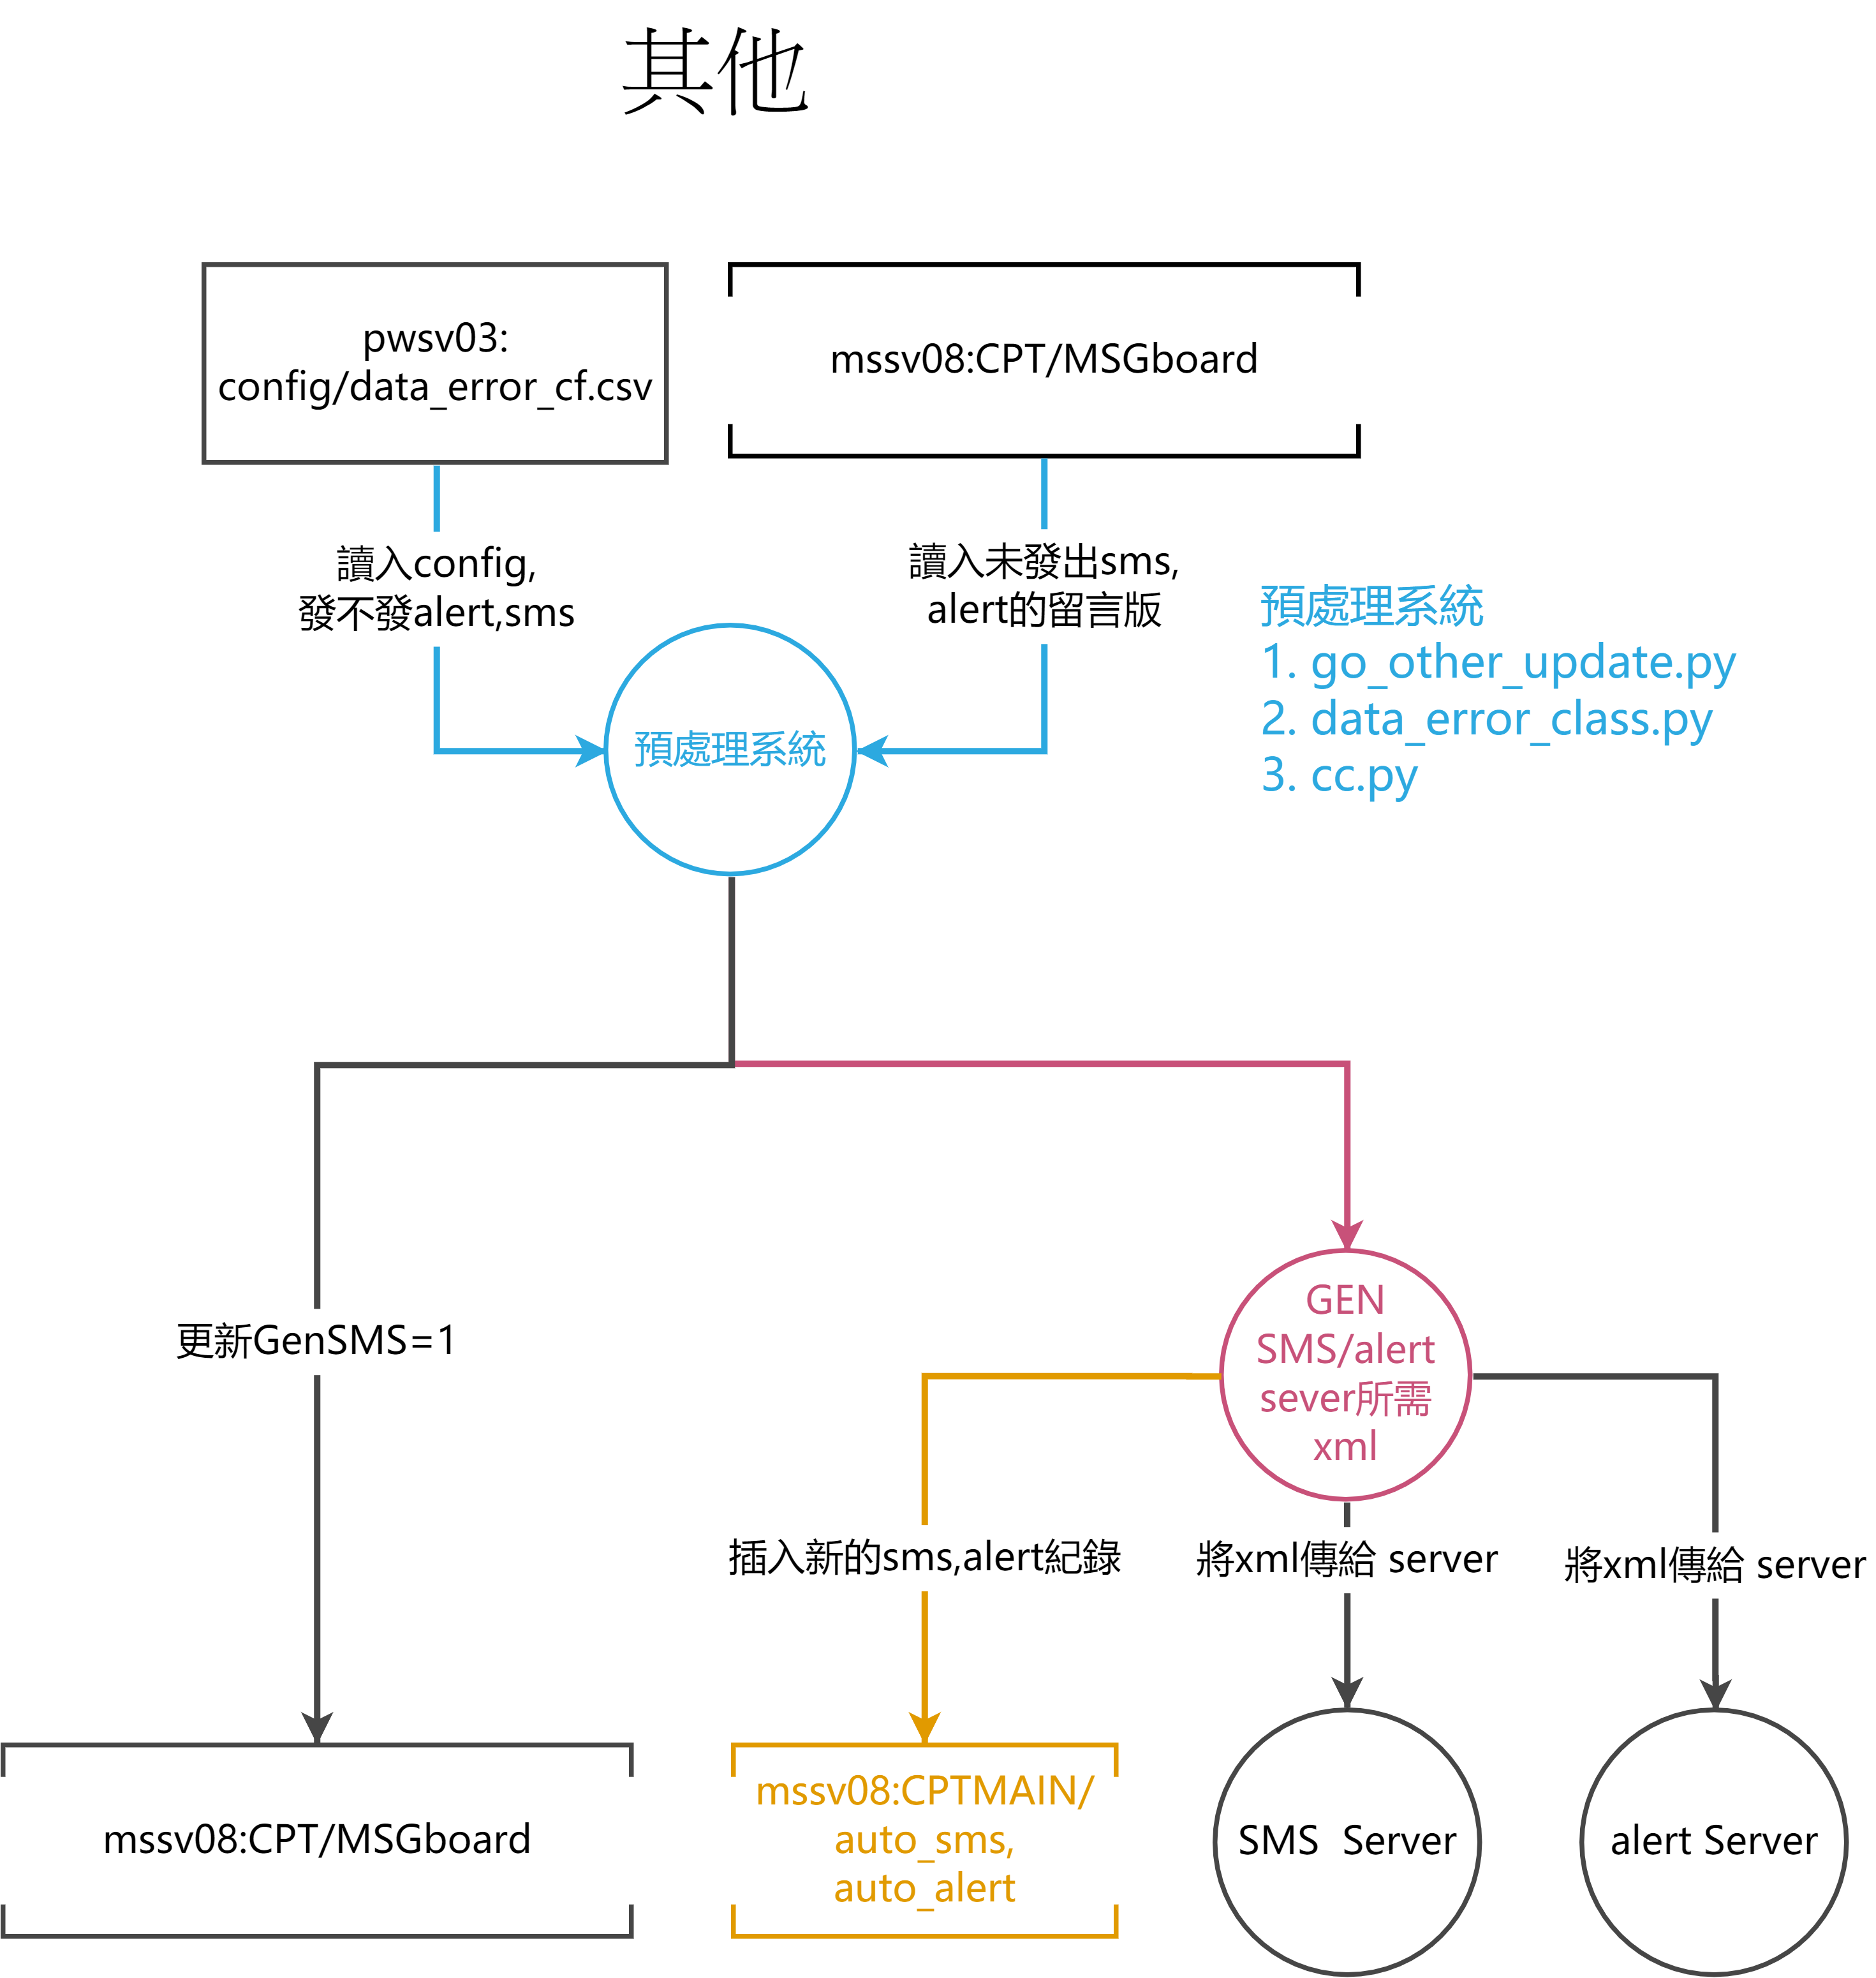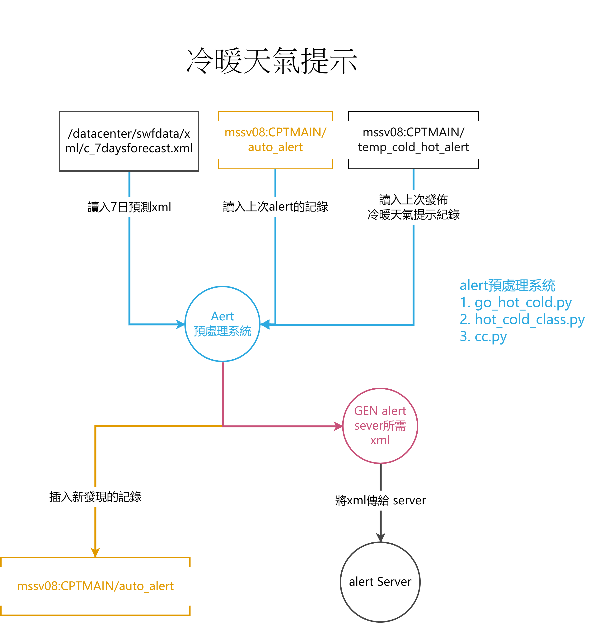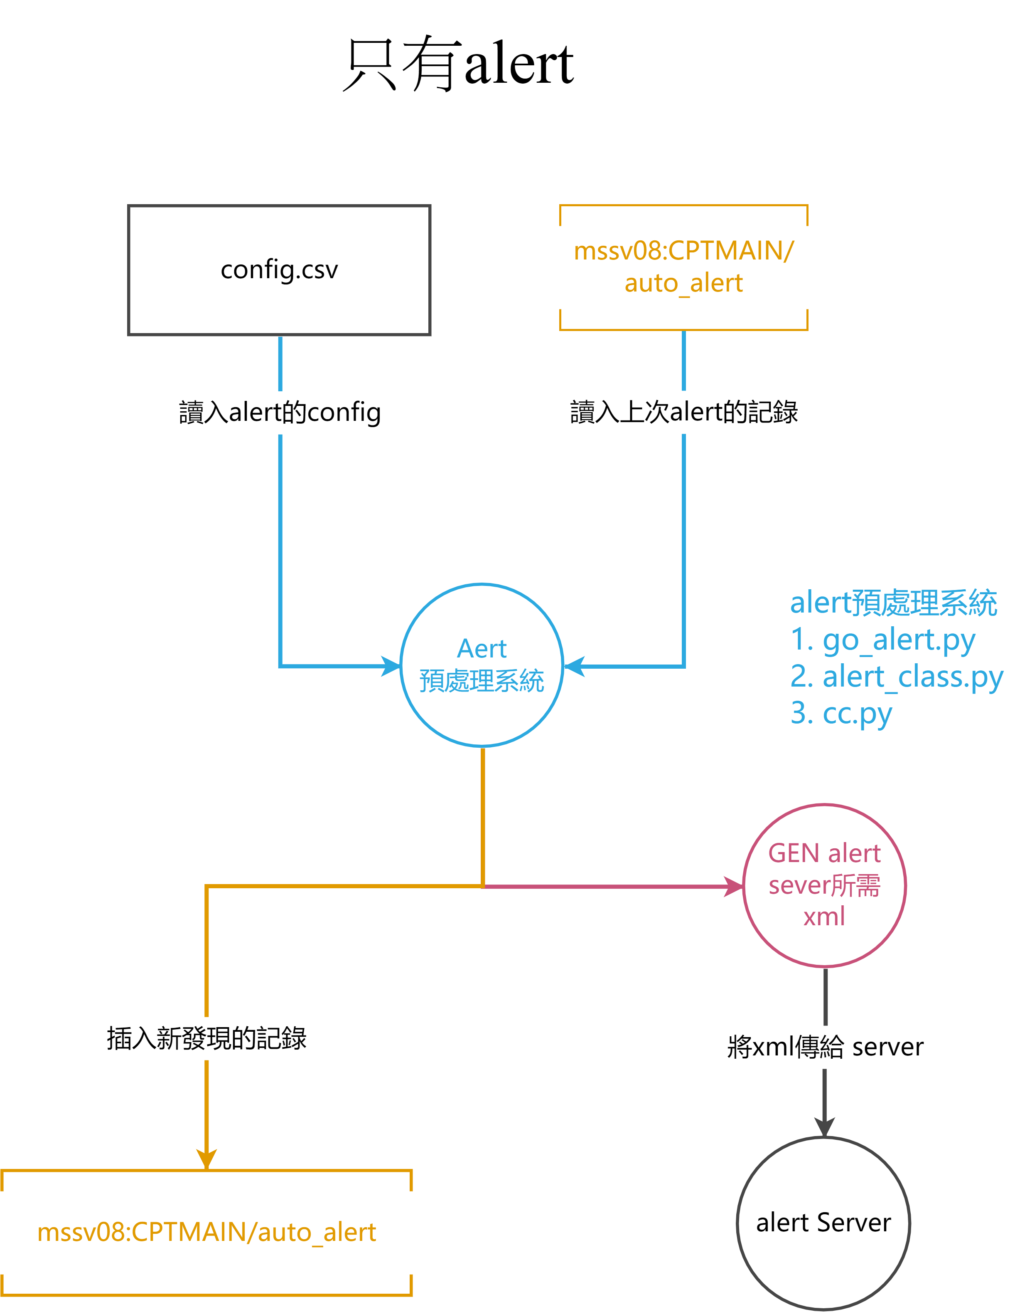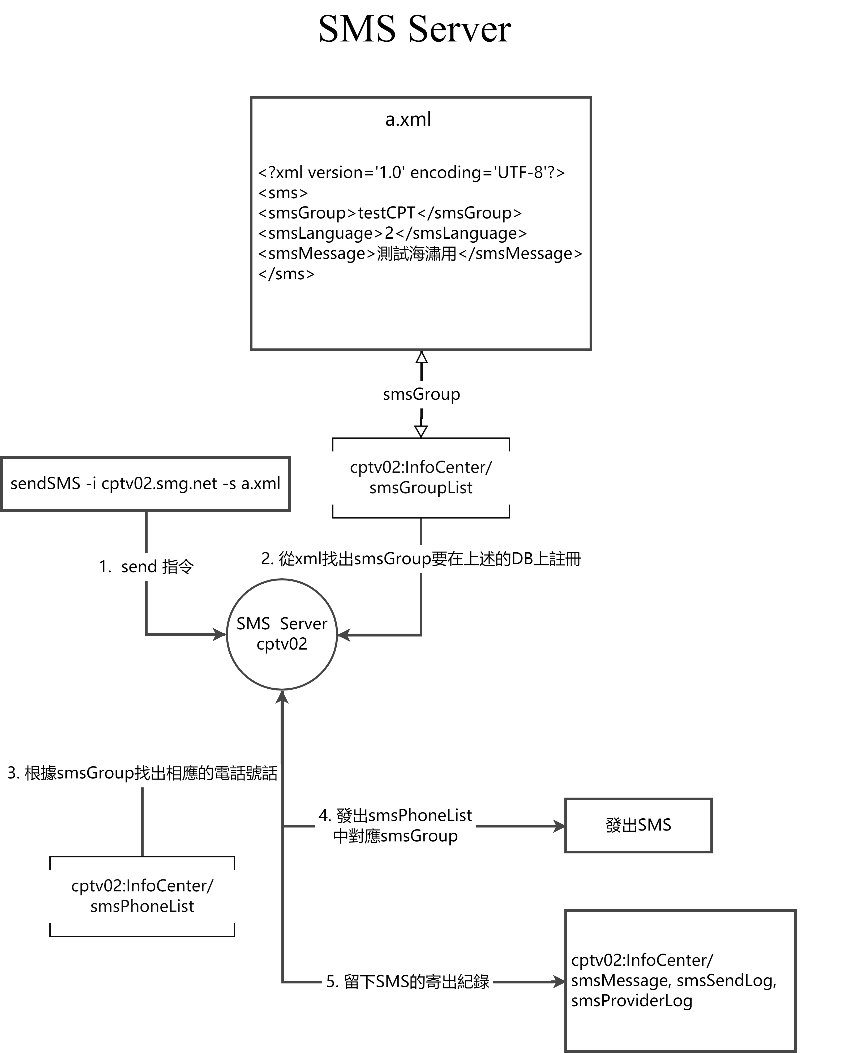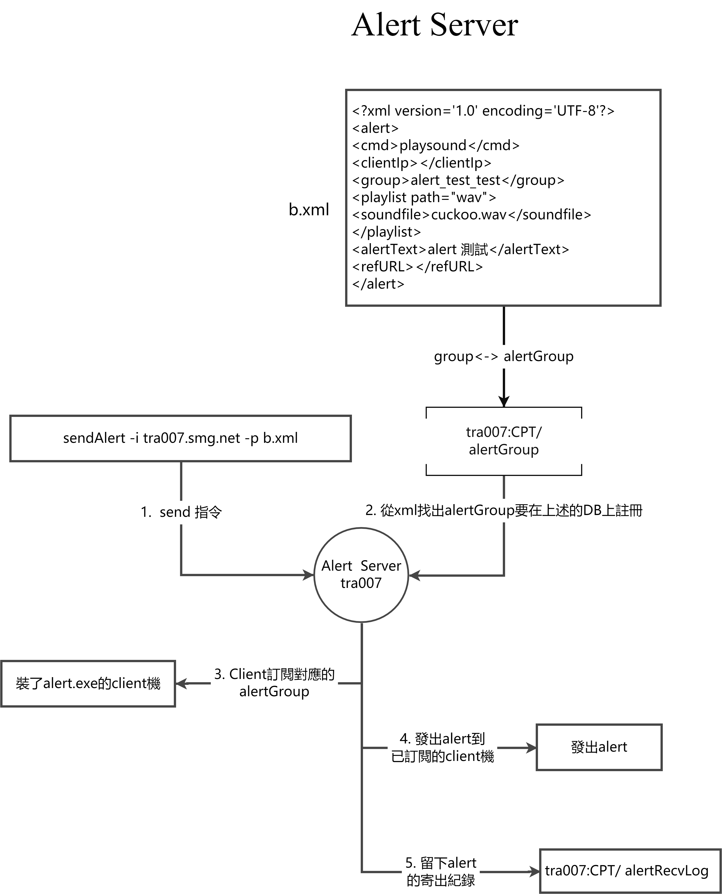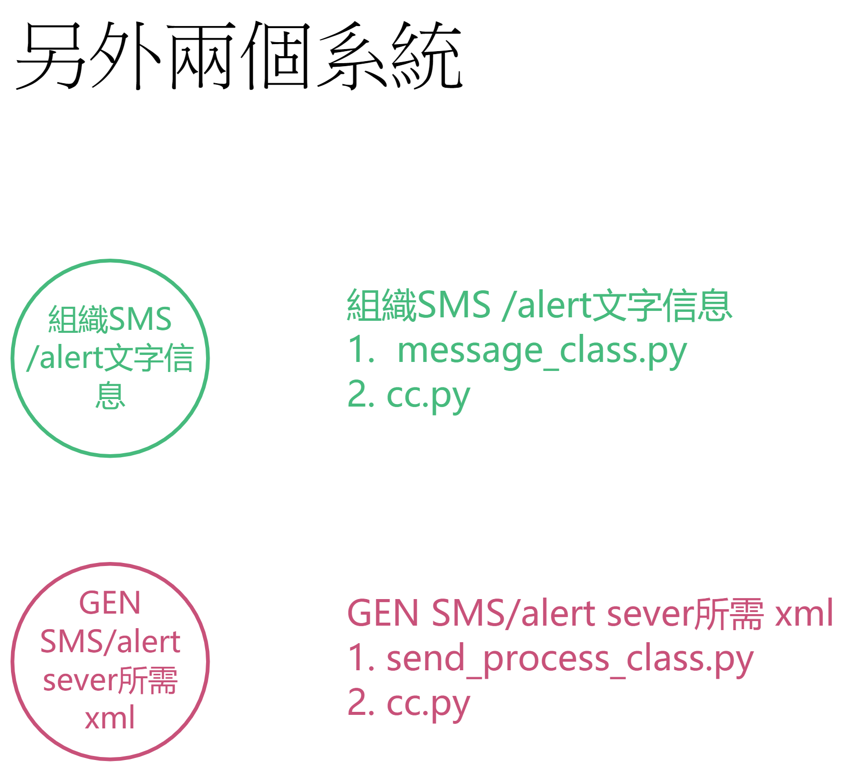

## 附錄

1. Sms Server

* 指令:

|  |
| --- |
| sendSMS -i cptv02.smg.net -s a.xml |

* a.xml 樣本

|  |
| --- |
| <?xml version='1.0' encoding='UTF-8'?>  <sms>  <smsGroup>testCPT</smsGroup>  <smsLanguage>2</smsLanguage>  <smsMessage>測試海潚用</smsMessage>  </sms> |

1. Alert Server

* 指令:

|  |
| --- |
| sendAlert -i tra007.smg.net -p b.xml |

* b.xml 樣本

|  |
| --- |
| <?xml version='1.0' encoding='UTF-8'?>  <alert>  <cmd>playsound</cmd>  <clientIp></clientIp>  <group>alert_test_test</group>  <playlist path="wav">  <soundfile>cuckoo.wav</soundfile>  </playlist>  <alertText>alert 測試</alertText>  <refURL></refURL>  </alert> |

全文完